
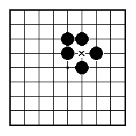
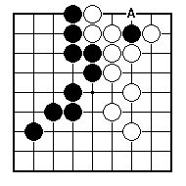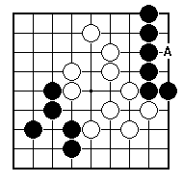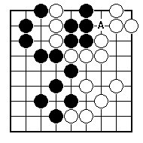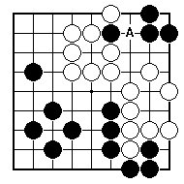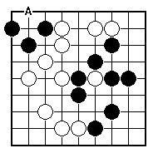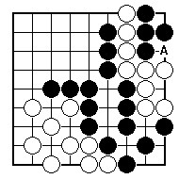
Would it be good or bad for White to play at A?

Would it be good or bad for Black to play at A?

Would it be good or bad for White to play at A?

Would it be good or bad for Black to play at A?

Would it be good or bad for White to play at A?

Would it be good or bad for White to play at A?

NAME:
BRITISH GO ASSOCIATION CERTIFICATE LEVEL 3 - SHEET 3

WASTED MOVES AND UNNECESARY MOVES

